Nama : Herly Herdiansyah Saputra
NIM : 055716397
Prodi : Sistem Informasi
Izin menjawab diskusi 6

Soal
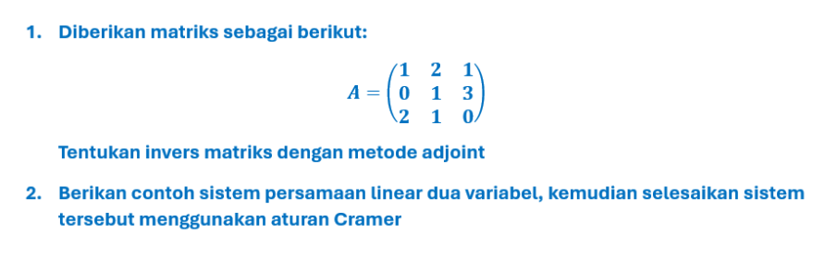

Jawaban
- Dik matriks: $A=\left(\begin{matrix}1 & 2 & 1 \\ 0 & 1 & 3 \\ 2 & 1 & 0\end{matrix}\right)$
Rumus invers matriks dengan metode matriks adjoint yang ada pada materi inisiai sesi 6 STMA4113 yaitu : $A^{-1}=\frac{1}{\det\left(A\right)}adj(A)$

- Menentukan Kofaktor Matriks (A)
$$C_{11}=+\left(\begin{matrix}1 & 3 \\ 1 & 0\end{matrix}\right)=\left(1⋅0\right)-\left(3⋅1\right)=-3$$
$$C_{12}=+\left(\begin{matrix}0 & 3 \\ 2 & 0\end{matrix}\right)=-(\left(0⋅0\right)-\left(3⋅2\right))=-\left(-6\right)=6$$
$$C_{13}=+\left(\begin{matrix}0 & 1 \\ 2 & 1\end{matrix}\right)=\left(0⋅1\right)-\left(1⋅2\right)=-2$$
$$C_{21}=+\left(\begin{matrix}2 & 1 \\ 1 & 0\end{matrix}\right)=-\left(\left(2⋅0\right)-\left(1⋅1\right)\right)=-\left(-1\right)=1$$
$$C_{22}=+\left(\begin{matrix}1 & 1 \\ 2 & 0\end{matrix}\right)=\left(1⋅0\right)-\left(1⋅2\right)=-2$$
$$C_{23}=+\left(\begin{matrix}1 & 2 \\ 2 & 1\end{matrix}\right)=-\left(\left(1⋅1\right)-\left(2⋅2\right)\right)=-3\left(-3\right)=3$$
$$C_{31}=+\left(\begin{matrix}2 & 1 \\ 1 & 3\end{matrix}\right)=\left(2⋅3\right)-\left(1⋅1\right)=6-1=5$$
$$C_{32}=+\left(\begin{matrix}1 & 1 \\ 0 & 3\end{matrix}\right)=-\left(\left(1⋅3\right)-\left(1⋅0\right)\right)=-3$$
$$C_{33}=+\left(\begin{matrix}1 & 2 \\ 0 & 1\end{matrix}\right)=\left(1⋅1\right)-\left(2⋅0\right)=1$$
Kofaktor $A=\left(\begin{matrix}-3 & 6 & -2 \\ 1 & -2 & 3 \\ 5 & -3 & 1\end{matrix}\right)$

- Menghitung Determinan Matriks A (det(A))
$$\det\left(A\right)=\left(\begin{matrix}1 & 2 & 1 & | & 1 & 2 \\ 0 & 1 & 3 & | & 0 & 1 \\ 2 & 1 & 0 & | & 2 & 1\end{matrix}\right)$$
$$\det\left(A\right)=\left(\left(1⋅1⋅0\right)+\left(2⋅3⋅2\right)+\left(1⋅0⋅1\right)\right)-(\left(2⋅1⋅1\right)+\left(1⋅3⋅1\right)+\left(0⋅0⋅2\right))$$
$$\det\left(A\right)=\left(0+12+0\right)-\left(2+3+0\right)$$
$$\det\left(A\right)=12-5=7$$
$$adj\left(A\right)=\left(\begin{matrix}-3 & 1 & 5 \\ 6 & -2 & -3 \\ -2 & 3 & 1\end{matrix}\right)$$
$$A^{-1}=\frac{adj(A)}{(A)}=\frac{1}{7}\left(\begin{matrix}-3 & 1 & 5 \\ 6 & -2 & -3 \\ -2 & 3 & 1\end{matrix}\right)=\left(\begin{matrix}-\frac{3}{7} & \frac{1}{7} & \frac{5}{7} \\ \frac{6}{7} & -\frac{2}{7} & -\frac{3}{7} \\ -\frac{2}{7} & \frac{3}{7} & \frac{1}{7}\end{matrix}\right)$$

- Contoh Persamaan Linear Dua Variabel:
$$\left\{\begin{matrix}2_{x}+3_{y}=12 \\ 3_{x}-y=7\end{matrix}\right\}$$Mengubah bentuk persamaan matriks $AX=B$:
$$\left(\begin{matrix}2 & 3 \\ 3 & -1\end{matrix}\right)\left(\begin{matrix}x \\ y\end{matrix}\right)=\left(\begin{matrix}12 \\ 7\end{matrix}\right)$$
- Menghitung Determinan Variabel $(D)$
$$D=\left(\begin{matrix}2 & 3 \\ 3 & -1\end{matrix}\right)=\left(2⋅-1\right)-\left(3⋅3\right)=-2-9=-11$$
- Menghitung Determinan Variabel $x(D_{x})$
$$D_{x}=\left(\begin{matrix}12 & 3 \\ 7 & -1\end{matrix}\right)=\left(12⋅-1\right)-\left(3⋅7\right)=-12-21=-33$$
- Menghitung Determinan Variabel $y(D_{y})$
$$D_{y}=\left(\begin{matrix}2 & 12 \\ 3 & 7\end{matrix}\right)=\left(2⋅7\right)-\left(12⋅3\right)=14-36=-22$$

- Menentukan nilai $x dan y$
$$x=\frac{D_{x}}{D}=\frac{-33}{-11}=3$$
$$y=\frac{D_{y}}{D}=\frac{-22}{-11}=2$$
Himpunan penyelesaiannya adalah {(3,2)}

